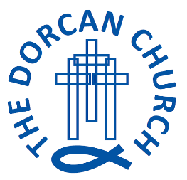

Application for Part-time Administrator

The recruitment and selection process will take place in October with the hope that the candidate will start as soon as possible thereafter.

Timescales for applications and selection

Monday 11th October 2021 noon | Closing date
Wednesday 20th October 2021 time TBC | Interviews to be held

How to apply

We would love to hear from you!
If you would like to have an informal chat or seek any clarification before making an application, then you are warmly invited to contact The Revd Trudie Wigley on 07505 652781 or email rev.trudie@wigley.org.uk to arrange this conversation.

In your application, we would ask that you:

- Submit a CV listing your past and current roles and responsibilities

- Provide a letter of no more than two sides of A4 exploring:

    - How your strengths, experience and skills might be used in this role
    - Your experience of on-line and social media tools
    - A leaflet, advertising flyer or social media advert that you have designed

Please submit your application, together with an indication of your availability for interview, to The Revd Trudie Wigley, rev.trudie@wigley.org.uk, or post to St. Paul's Drive, Covingham, Swindon, Wiltshire, SN3 5BY. We know that much time, effort and thought goes into making an application and therefore we will contact all applicants after the closing date.

References
Please provide us with names, email addresses and telephone numbers of two referees. These should include a person who you most recently have been responsible to, and a colleague or friend you have known for at least five years. These referees will not be contacted prior to interview without your consent.

Thank you for considering applying for this position
and we look forward to hearing from you.

The team at Dorcan Church

